

BIOLOGICAL SCIENCES

STAGE 2 SAMPLE EXAMINATION

Section 7 of the WACE Manual: Revised edition 2008 outlines the policy on WACE examinations.

Further information about the WACE Examinations policy can be accessed from the Curriculum Council website at http://newwace.curriculum.wa.edu.au/pages/about_wace_manual.asp.

The purpose for providing a sample examination is to provide teachers with an example of how the course will be examined. Further finetuning will be made to this sample in 2008 by the examination panel following consultation with teachers, measurement specialists and advice from the Assessment, Review and Moderation (ARM) panel.
2008/24179



Western Australian Certificate of Education, Draft Sample Examination

Question/answer booklet

BIOLOGICAL SCIENCES
DRAFT
Please place your student identification label in this box
STAGE 2

Student Number: In figures

In words

Time allowed for this paper
Reading/planning time before commencing work: Ten minutes
Working time for paper: Three hours

Material required/recommended for this paper

To be provided by the supervisor
Question/answer booklet
Multiple choice answer sheet

To be provided by the candidate
Standard items: pens, pencils, eraser, correction fluid, highlighter and ruler.

Special items: calculators satisfying the conditions set by the Curriculum Council for this course.

Important note to candidates
No other items may be taken into the examination room. It is your responsibility to ensure that you do not have any unauthorised notes or other items of a non-personal nature in the examination room. If you have any unauthorised material with you, hand it to the supervisor before reading any further.

Structure of this paper

Section | Number of questions available | Number of questions to be attempted | Suggested working time minutes | Marks available
One  Multiple choice | 20 | 20 | 30 | 40 (20%)
Two  Short answers | 8 | 8 | 90 | 120 (60%)
Three  Extended answers | 2 | 2 | 60 | 40 (20%)
 |  | Total marks |  | 200 (100%)

Instructions to candidates

- The rules for the conduct of Curriculum Council examinations are detailed in the Student Information Handbook. Sitting this examination implies that you agree to abide by these rules.

- Answer the questions according to the following instructions:

Read every question carefully before you answer.

Section One Answer all questions, using a 2B, B or HB pencil, on the separate Multiple choice answer Sheet.

Section Two Answer in the spaces provided in this Question/answer booklet. Do not answer this section in the Standard answer book. A blue or black ball point or ink pen (not pencil) should be used.

Section Three Write your answers in the Standard answer book. Use a blue or black ball point or ink pen (not pencil) for this section.

3. At the end of the examination your Question/answer booklet should be attached to the front of the Standard answer book/s with the paper binder provided.

Section One: Multiple-choice 40 marks

This section has twenty questions. Answer these questions on the multiple-choice answer sheet is provided. Each question is worth two marks.

Suggested working time: 30 minutes.
_____________________________________________________________________

Question 1
The destruction of all bacteria would bring life on earth to an end because:

- the organisms that feed on bacteria would starve, starting a chain of starvation through the food webs and ecosystems.
- they are the hardest organisms to kill so the chemicals used would poison the earth.
- the available nutrients would be ‘locked up’ in the undecayed vegetation and animal carcasses.
- the diseases bacteria caused would no longer keep the populations in check so there would be no food left.

Questions 2 and 3 refer to the diagrams below of an organism viewed under a light microscope at varied magnifications.

The magnification of A is 600x and the organism is known to be 150µm long.

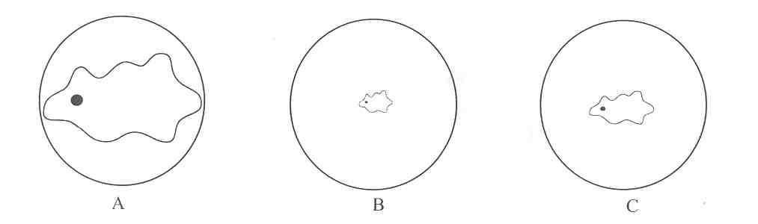

Question 2
What is the magnification of the microscope for diagram C?
- 180x
- 120x
- 240x
- 400x

Question 3
What is the field of view (field diameter) of the microscope for diagram B?
- 0.09 mm
- 900 mm
- 9.00mm
- 0.90 mm
Questions 4 and 5 refer to the following diagram of a plant cell:

For copyright reasons this diagram cannot be reproduced in the online version of this document.

[From: Raven, Evert & Eichhorn, 1992]

Question 4
It is not known whether this cell has been taken from the root or the shoot of the plant. Which structure would be most helpful in deciding this question?
- D
- A
- G
- E

Question 5
Which of the following is not an important function of structure F in plants?
- It controls the movement of substances into and out of the cell
- It prevents the cell from rupturing following the uptake of water
- It provides structural rigidity to the plant as a whole
- It assists in water movement from the roots to the shoot

Question 6
If a live salt water crayfish is put into a bucket of freshwater it will die because:

- there is less oxygen in freshwater than salt water.
- there is no food in the fresh water for the salt water crayfish.
- the temperature fluctuations are too great for the crayfish to tolerate.
- there would be an increased amount of water enter the cells causing tissue damage and death.

Question 7
A flowering plant has a haploid chromosome number of 8. Which of the following statements about the plant is true?

- Its root cells contain 4 chromosomes
- Its egg cells contain 16 chromosomes
- Its leaf cells contain 32 chromosomes
- Its pollen cells contain 8 chromosomes
Questions 8 and 9 refer to the following pedigree showing the inheritance of chestnut (red/brown) coat colour in horses:

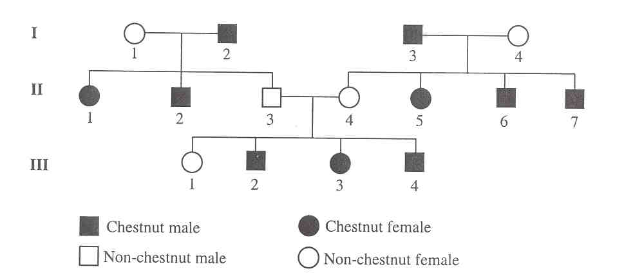

Question 8
Gender (male or female) in horses is inherited in the same way as humans. Therefore, which of the following statements is true?

- Individual III 4 must have inherited a Y chromosome from I 3
- Individuals II 2 and II 3 must have different genes on their Y chromosomes
- Individual III 1 must have inherited an X chromosome from I 4
- Individuals III 1 and III 3 must have identical genes on their X chromosomes

Question 9
From the pedigree it can be concluded that chestnut coat colour in horses is inherited as:
- a dominant autosomal gene
- a recessive sex-linked gene
- a recessive autosomal gene
- a dominant sex-linked gene

Question 10
Which is the correct path of water transport in plants, listed from uptake into the plant to exit from the plant?

- roots, root hair cells, phloem tissue, leaves, stomata
- root hair cells, roots, phloem tissue, leaves, stomata
- stomata, leaves, xylem tissue, roots, root hair cells
- root hair cells, roots, xylem tissue, leaves, stomata

Question 11
When rabbits were introduced into Australia they bred rapidly and by the end of the 19th century they were in plague proportions. The best reason for the success of rabbits in Australia is that:

- the rabbits were able to adapt themselves to a new climate.
- there were several natural predators of rabbits in Australia.
- there was little competition between rabbits and other species.
- the burrows seldom flooded in Australia compared with their country of origin.

Question 12
All animals produce nitrogenous waste products that need to be excreted. There are three types of nitrogenous waste products produced by animals:

Decreasing
solubility
in water

Ammonia
Urea
Uric acid

Based on this information, select the correct statement.
- Because of the need to conserve water in a desert environment, reptiles produce uric acid
- Mammals urinate frequently so they produce ammonia
- Birds need to keep their body weight down for flight so they produce ammonia
- Fish need to reduce the amount of water in their bodies so they produce uric acid.

Question 13
Fungi differ from green plants in that they typically:

- are unicellular.
- do not grow in the presence of light.
- do not have cell walls.
- they require an external food source.

Question 14
Vascular plants adapted to live by floating on water are most likely to show which of the following adaptations?

- No stomata on the leaves only on the stems
- Stomata on the upper surfaces of the leaves
- Stomata on stems as well as leaves
- Stomata located in pits on the leaves

Question 15
The following table summarises data measured for some soft-bodied aquatic animals collected from a pond.

Animal | Length  (cm) | Body weight (g) | Surface area (cm²)
A | 4 | 4 | 12.2
B | 2 | 0.5 | 0.8
C | 1.5 | 0.4 | 0.4
D | 2 | 1.5 | 10.5

Which of these animals has the greatest ratio of surface area to body weight?
- animal A
- animal B
- animal C
- animal D

Questions 16 and 17 relate to the following diagram of a food web for a fictitious community occurring on a small island.

Question 16
Food webs imply information about the biomass of the different organisms and the energy movements between them. Which of the following statements about the food web is correct?

- Biomass in the manticores may be returned to the panotians
- Solar energy recycles through the food web
- Heat energy is gained at each step of the food web
- Total biomass increases at each step of the food web

Question 17
Which of the following statements about the biomass of the organisms in this food web is correct?

- The biomasses of the unicorns, the blemmies and the skiapods will be equal
- The biomass of the skiapods will exceed the biomass of the cameleopards
- The biomass of the manticores will exceed the biomass of the panotians
- The biomass of the prances will equal the biomass of the panotians.
Question 18
A woman, who was a keen gardener, won a number of awards at flower shows for her plants with deep blue flowers. She gave one of these prize winning plants to a friend who planted it in his garden. The following season, when the plant re-flowered, he was surprised to see that it had produced a large number of flowers, all of which were pink. He asked his gardener friend for her comments.
The gardener could reasonably state that:

- the different soil in the new area had modified the expression of the gene controlling flower colour.
- the change in the flower colour had been caused a mutation in the gene controlling flower colour.
- the change had been caused by the loss of the chromosome or part of the chromosome controlling flower colour.
- fertilisation of the prize winning plant by pollen from a nearby pink-flowering plant would have caused the colour change.

Questions 19 and 20 refer to the following information:

Five pots were set up with plant cuttings in soil mix. (Note: All diagrams are drawn to the same scale.)

Question 19
Which of the following pots would be the most useful to test the hypothesis that 'the deeper a cutting is planted the more likely it is to grow into a new plant?

- Pots I and II
- Pots III and V
- Pots III and IV
- Pots I and IIl

Question 20
Which of the following changes to the procedure used would be least likely to improve the reliability of the above investigation?

- Use the same species of plant in all five set-ups
- Water the pots more often to promote growth
- Make several of each of the five types of set-up
- Repeat the experiment several times

END OF SECTION ONE
Section Two—Short Answers 120 marks
This section contains eight questions with parts.
Answer questions in the spaces provided. Diagrams may be used in your answer. Use pencil for diagrams and make sure diagrams are clear and labelled.

Suggested time: 90 minutes
_____________________________________________________________________

Question 1 [18 marks]

An experiment on the effects of temperature on the rate of photosynthesis has been carried out on two different aquatic plants. The number of bubbles given off by each plant during one minute was counted. Each count was repeated three times at each different temperature and the average results are shown in the following table.

 | Average number of bubbles per minutes
Temperature  (ºC) | Plant A | Plant B
5 | 4 | 13
10 | 10 | 27
15 | 22 | 65
20 | 43 | 97
25 | 60 | 123
30 | 66 | 133
35 | 30 | 138
40 | 0 | 120

- Graph this data on the grid provided below.
[5 marks]

What is the relationship between temperature and the rate of photosynthesis? Use evidence from the data to support your statement.
[3 marks]

____________________________________________________________________________

____________________________________________________________________________

____________________________________________________________________________

- From your graph, state the rate of bubbles given off from plant A and plant B at 28 ºC.
[2 marks]

Plant A: ________________ Plant B: __________________

- How do the plants differ with respect to:

    - tolerance to high temperatures? Give evidence from the data to support your answer.
[3 marks]

____________________________________________________________________________

____________________________________________________________________________

____________________________________________________________________________

    - optimal temperature for photosynthesis?
(2 marks]

____________________________________________________________________________

____________________________________________________________________________

____________________________________________________________________________

- Which plant would most likely be found in shallow water? Give reasons for your answer.
[3 marks]

____________________________________________________________________________

____________________________________________________________________________

____________________________________________________________________________

Question 2 [23 marks]

a. The diagram below represents some of the relationships in biogeochemical cycles.
The numerals I, II, III and IV represent compounds.
(i)The group of organisms which is responsible for converting materials at G to IV (a form which is useable by the plant), is called
[1 mark]
_______________________________________________

(ii) The most significant chemical element in the material IV moving through G and H is
[1 mark]
_______________________________________________

(iii) Arrows A, B, C and D represent the cycling of materials as a result of TWO processes occurring in plants which are
[2 marks]
______________________ and _________________________

(iv) Material I is
[1 mark]
_______________________________________________

(v) By what means do materials from K and H move into the plant?
[2 mark]
______________________ and _________________________

(vi) Energy flow and material cycling become most closely related when radiant energy at L is converted by the tree to chemical energy in the plant tissue in the form of
[1 mark]
_______________________________________________

(vii) Arrows M and N are part of which cycle? [1 mark]
_______________________________________________

(viii) Substance II is [1mark]
_______________________________________________

[Adapted from: University of Western Australia, 1973]

b. A mallee scrub community is made up of species of Eucalyptus, a shrub layer of Acacia and Cassia plants and several species of herbaceous annuals (herbs). During the winter and spring the herbs provide buds and flowers as food for the mallee fowl, but as increasing summer heat diminishes this food supply, the birds feed on fruits on the smaller shrubs.

In January, Acacia and Cassia seeds begin to fall and serve as the main food source for the mallee fowl until the approach of winter when the herbs become available once more. The birds will consume any seed-eating ants and beetles they encounter.
[From: Department of Conservation and Land Management, 2000]

Pigeons, parrots, other small birds, ants and beetles share the mallee fowl’s main diet, the Acacia and
Cassia seeds.

Although foxes consume beetles, small birds and lizards, they also eat 35% of the eggs laid by the mallee fowl. Lizards will make a meal of
any exposed mallee fowl eggs they find.

foxes

lizards
small birds

mallee fowl

ants beetles

pigeons
parrots

Acacia, herbs
Cassia

(i) What is the original source of energy used by the lizards?
[1 mark]

____________________________________________________________________________

(ii) Explain why the amount of energy available to the foxes differs from the amount of energy available to the herbivores.
[3 marks]

____________________________________________________________________________

____________________________________________________________________________

____________________________________________________________________________

____________________________________________________________________________

(iii) A field officer has observed that in a summer when there is an unusual increase in the number of parrots, there is a significant decrease in the number of beetles. Suggest an explanation for this, based on the food web shown above.
[3 marks]

____________________________________________________________________________

____________________________________________________________________________

____________________________________________________________________________

____________________________________________________________________________

(iv) When examining mallee fowl nesting mounds, it is possible to determine whether foxes were visiting them.
Explain each of the following observations:

(1) After poisoned eggs that were placed in one mound were eaten, the destruction of eggs by foxes immediately stopped on that mound and on the six other mounds that had been previously raided.
[3 marks]

____________________________________________________________________________

____________________________________________________________________________

____________________________________________________________________________

____________________________________________________________________________

(2) After one month these mounds were again raided by foxes along with two mounds that had not been previously raided.
[3 marks]

____________________________________________________________________________

____________________________________________________________________________

____________________________________________________________________________

____________________________________________________________________________

Question 3 [9 marks]

A biologist collected 768 specimens of an estuarine snail from 4 different square metre plots on the mud bank of the Swan River.

- Calculate the density of the snail population on this mud bank.
[2 marks]

____________________________________________________________________________

____________________________________________________________________________

- The biologist chose 4 different areas by throwing a wire frame onto the mud bank from a distance. Why was this method used?
[2 marks]

____________________________________________________________________________

____________________________________________________________________________

- If the biologist wished to know the total population of snails in the area, explain what additional information would be required.
[3 marks]

____________________________________________________________________________

____________________________________________________________________________

____________________________________________________________________________

- Would this sampling technique be useful for studying the fish populations in the river? Explain your answer.
[2 marks]

____________________________________________________________________________

____________________________________________________________________________

____________________________________________________________________________

[Adapted from: University of Western Australia, 1974]
Question 4 [10 marks]

A biologist seeking to determine the degree of relationship between three broad-winged hawks, Buteo swainsoni, B. platypterus and B. lineatus, gathered the data below.

For copyright reasons these illustrations cannot be reproduced in the online version of this document.

 | 1 | 2 | 3
 | For copyright reasons the contents of this table cannot be reproduced in the online version of this document.

[Illustrations and adapted table from: Biological Sciences Curriculum Study, 1976]

- To which phylum and class do these organisms belong?
[2 marks]

Phylum: __________________________________________________

Class: ___________________________________________________

- State two common features of this class.
[2 marks]

____________________________________________________________________________

____________________________________________________________________________

- Which of these two species are most closely related?
[1 mark]

____________________________________________________________________________

- Which combination of characteristics in the table supports your answer above?
[3 marks]

____________________________________________________________________________

____________________________________________________________________________

____________________________________________________________________________

____________________________________________________________________________

- Suggest two (2) other possible observations that would support your answer to c. above.
[2 marks]

____________________________________________________________________________

____________________________________________________________________________

____________________________________________________________________________

Question 5 [9 marks]

In the life cycle of the liver fluke, the adult parasite in the bile duct of sheep produces millions of eggs that are passed out in the host’s faeces. Some of the eggs are washed into ponds and give rise to miracidia which bore into certain species of snail. In this host, the development continues and eventually millions of cercariae are released which swim to and climb up the vegetation at the edge of the pond. Here they form cysts and may be digested by a sheep grazing on the plants, and the cycle starts again.

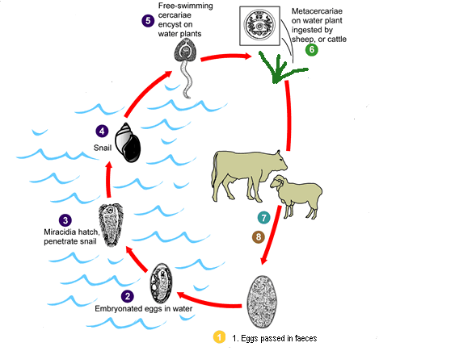

- Explain why the adult fluke produces so many eggs.
[2 marks]

____________________________________________________________________________

____________________________________________________________________________

- Give two possible ways in which the spread of the liver fluke may be controlled.
[2 marks]

Method 1____________________________________________________________________

____________________________________________________________________________

Method 2____________________________________________________________________

____________________________________________________________________________

- What is the role of the snail in the life cycle of the liver fluke?
[1 mark]

____________________________________________________________________________

- State one structural adaptation of the liver fluke and describe how it is related to this parasitic life cycle.
[2 marks]

____________________________________________________________________________

____________________________________________________________________________

- State two behavioural adaptations shown by the liver fluke in its life cycle.
[2 marks]

____________________________________________________________________________

____________________________________________________________________________

Question 6 [10 marks]
In mice, the condition of frizzy fur is uncommon. A pet shop owner noticed one mouse with frizzy fur in a litter in the shop. It gained so much attention from shoppers wishing to buy it, he wanted to breed more. Use the pedigree is given below to answer the questions.

I

1 2

II

1 2 3 4

II 4 is a male with frizzy fur.

- What proportion of the gametes from animal 2 in generation I carry the frizzy fur allele?
[1 mark]

____________________________________________________________________________

- What is the probability of producing offspring with frizzy fur from these parents? Show your working.
[3 marks]

____________________________________________________________________________

____________________________________________________________________________

_____________________________________________________________________________

- Which cross among the mice shown would have the highest probability of producing frizzy furred offspring? Show your working.
[3 marks]

____________________________________________________________________________

____________________________________________________________________________

____________________________________________________________________________

- Determine whether II 2 was homozygous or heterozygous? Show your working.
[3 marks]

____________________________________________________________________________

____________________________________________________________________________

____________________________________________________________________________

Question 7 [15 marks]

The diagram below represents a transverse section of a leaf. Examine the diagram carefully and answer the questions that follow.

- Which of the cells labelled would contain the most chloroplasts? Explain why.
[2 marks]

____________________________________________________________________________

____________________________________________________________________________

____________________________________________________________________________

- What is the function of the chlorophyll in the chloroplasts?
[1 mark]

____________________________________________________________________________

- There are two types of tissue in the structure labelled D. State two functions for structure D and relate these to the tissues located in D.
[4 marks]

Function 1: __________________________________________________________________

____________________________________________________________________________

Function 2: __________________________________________________________________

____________________________________________________________________________

- Name and describe structure A and explain how it can be used to indicate the habitat in which the plant lives.
[4 marks]
Name:___________________

Description:_________________________________________________________________

Explanation: _________________________________________________________________

____________________________________________________________________________

____________________________________________________________________________

- The cells on either side of structure E control the size of the opening. Explain the changes in the size of the opening during the course of a summer day.
[4 marks]

____________________________________________________________________________

____________________________________________________________________________

____________________________________________________________________________

____________________________________________________________________________

____________________________________________________________________________

____________________________________________________________________________

Question 8 [26 marks]

- Fill in the following showing the stages in the life cycle of a fly.
[3 marks]
Adult

X

- Which two reproductive processes need to occur at X for this life cycle to continue?
[2 marks]

______________________________

______________________________

- Explain one advantage of this type of life cycle for the fly.
[2 marks]

___________________________________________________________________________

___________________________________________________________________________

- Fill in the following table to compare asexual and sexual reproduction.
(6 marks]

Feature | Asexual  Reproduction | Sexual  Reproduction
number of parents involved
type of cell division involved
example of an organism using each method

Flowers of Anigozanthos manglesii, the floral emblem of Western Australia

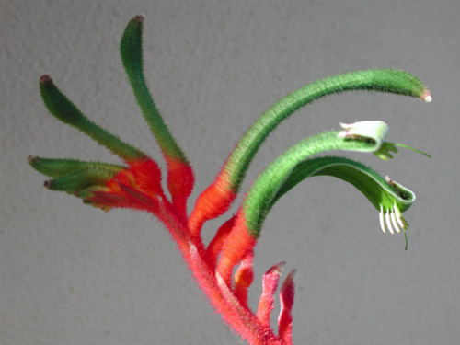
A
B
C
From: Pawlan, n.d.

- Name and state the function of parts A and B labelled on the diagram.
[4 marks]

A. _________________ _______________________________________________

B. _________________ _______________________________________________

- C contains nectar. Explain how pollination could occur in this flower and give reasons for your answer.
[3 marks]

_____________________________________________________________________________

_____________________________________________________________________________

_____________________________________________________________________________

- What are the main structural differences between eggs and sperm? [2 marks]

____________________________________________________________________________

_____________________________________________________________________________

- The eggs of different organisms are treated in very different ways once they have been laid. Some parents no longer have any more to do with their offspring once the eggs have been produced, while others take considerable time and effort in the care of the eggs. State one advantage and one disadvantage of each type of treatment.
[4 marks]
 | No parental care of eggs  e.g. fish | Extended parental care of eggs  e.g. birds
Advantage
Disadvantage
END OF SECTION TWO
Section Three—Extended Answers 40 marks

Section Three consists of two questions, with four parts to each.
Answer two parts from Question 1 and two parts from Question 2.
Each part carries ten (10) marks.

Answer Section Three in the standard answer book. Answers may be presented in a combination of different ways provided they communicate your ideas effectively.
You may choose to:
- present a clearly labelled diagram or flow chart
- write notes beside a clear diagram
- write lists of points, with sentences which link them
- write concisely worded sentences
- use some other appropriate way to present ideas.

Suggested working time: 60 minutes
___________________________________________________________________

Question 1 [20 marks]

Answer two parts of this question

1A i. Describe the role of the different nutrients that are required for the structure and function of all living organisms.

ii. Compare the ways that carnivores, omnivores and parasites acquire nutrients. Give examples to support your answer.
[10 marks]

1B Describe the forms and amounts of energy flowing through an ecosystem.
[10 marks]

1C A cat breeder specialises in breeding female tortoise-shell cats which have coats that are black with yellow patches. She tried to produce male tortoise-shell cats by making the following crosses:
Yellow female x black male - this produced female tortoise-shell and yellow male kittens.
Black female x yellow male - this produced female tortoise-shell and black male kittens.

i. Explain the inheritance pattern for coat colour in these cats.

ii. What coat colour kittens would be produced from crossing a tortoise-shell with a black male? Show your working.
[10 marks]

1D i. Outline the stages in the cell cycle.

ii. Describe the features of mitosis that make it suitable for its role in growth, repair and asexual reproduction.
[10 marks]
Question 2 [20 marks]

Answer two parts of this question.

2A Explain the adaptations of land animals to reproduce sexually. Give examples to support your answer.
[10 marks]

2B Explain the changes in population dynamics before and after a predator species is removed from the ecosystem.
[10 marks]

2C i. Fish out of water die even though air contains 20% oxygen and water only contains about 4% oxygen. Explain why this happens.

ii. Fish from a marine aquarium were inadvertently placed in a bucket of freshwater while the tank was being cleaned. Would the fish survive? Explain your answer.
[10 marks]

2D Explain the roles of photosynthesis and respiration in the cycling of matter.
[10 marks]

END OF PAPER

ACKNOWLEDGEMENTS

SECTION ONE

Questions 4 & 5 Diagram from: Raven, P.H., Evert, R.F., & Eichhorn, S.E. (1992). Biology of plants (5th ed.), New York: Worth, p. 20, fig. 2-6.

SECTION TWO

Question 2 Adapted from: University of Western Australia. (1973). Biology: Leaving Certificate Examination, 1973: Leaving level. Western Australia: University of Western Australia, p. 22.

Question 3 Adapted from: University of Western Australia. (1974). Biology: Leaving Certificate Examination, 1974: Leaving level. Western Australia: University of Western Australia, p. 16.

Question 4 Illustrations and adapted table from: Biological Sciences Curriculum Study. (1976). Diversity and unity through time. Philadelphia: W.B. Saunders.

Question 5 Diagram from: Department of Conservation and Land Management. (2000). Western shield: A unit of work on threatened species for middle childhood: Action pack. Kensington, WA: Department of Conservation and Land Management, p. 13. Retrieved April, 2008, from http://www.naturebase.net/pdf/plants_animals/western_shield/ws_action_pack.pdf.

Question 6 Image from: Wikimedia Commons. (n.d.). Fasciola lifecycle.gif. Retrieved April, 2008, from http://commons.wikimedia.org/wiki/Image:Fasciola_LifeCycle.gif.

Question 9 Photograph from: Pawlan, M. (n.d.). Kangaroo paw information page. Retrieved April, 2008, from http://www.pawlan.com/Monica/xanthor/kangaroo.html.

Published by the Curriculum Council of Western Australia
27 Walters Drive
OSBORNE PARK WA 6017

